PROJECT REPORT ON ATM MACHINE PROGRAMMING WITH JAVA

First of all, I would like to thank my lecturer **Mr. Cittaranjan Ghosh** for helping me to acquire knowledge of “**Java Programming Language**”. At the same time, he gave me the opportunity to learn something new related to our module like constructors, methods, unit testcases, MYSQL etc.

This assignment is based on developing an ATM (Automated Teller machine) using “**Java Programming Language**” so that it will become more users friendly to interact.

Besides, I also added text files for user’s records that are directly linked with this program. It is so called a heart of this program where all the functions depend on it.

Name: Lakshmi Narayanan’s

Batchcode:7671

Batch Center:Chennai-chromepet

## Table of Contents

ACKNOWLEDGEMENT

INTRODUCTION

MODULES EXPLANATIONS

First Things First

Function (Deposit)

Function (withdraw)

Function (Balance checking)

Function (Account details)

Function (Transaction details)

Function (Deactivate Account)

JAVA DATABASE CONNECTIVITY WITH MYSQL EXPLANATION

function database connectivity

function user checking

function 3service layer

DATABASE SERVICE LAYER CODES

Function deposit

Function withdrawal

Function balance check

Function Account details

Function Transaction details

Function Deactivation account

EXCEPTIONSCLASSES

Function codes Explanations

UNIT TEST CASESCLASSES

test codes Explanations

Assert equals for deposit

Assert not equals deposit

Assert equals for withdrawal

Assert not equals withdrawal

Assert equals for Balance check

Assert not equals Balance check

Assert equals for Account details

Assert not equals Account details

Assert equals for Transaction details

Assert not equals Transaction details

Assert equals for Balance check

Assert not equals Balance check

USER VALIDATIONCLASSES

code Explanation

# INTRODUCTION

This assignment is based on developing an ATM (Automated Teller machine) using “**Java Programming Language**” so that it will become more users friendly to interact.

Besides, i also added text files for user’s records that are directly linked with this program. It is so called a heart of this program where all the functions depend on it.

# SOFTWARE REQUIRMENTS:

In this documentation we have given explanations of how to interact successfully with this ATM (Automated Teller Machine). We have explained here step by step so that it will surely help users to become more user friendly with it. Below are our explanations:

### *First Things First:*

Before execute this program users need to do some works so that it will run properly into their system. First they need to make sure their system is having “JDK”. If they don’t have it then they can download from this below link:

[**http://www.oracle.com/technetwork/java/javase/downloads/jdk7-downloads-1880260.html**](http://www.oracle.com/technetwork/java/javase/downloads/jdk7-downloads-1880260.html)

Depending on their system (Windows 64bit/32bit) they need to download and install. Then they need to add the “JAVA” files to their system “PATH” so that the system can run the program from CMD (Command Prompt). The path will show something like this “**C:\Program Files (x86)\Java\jre1.8.0_25\bin;**”. Now just add the address besides the current path directory and save it.

**ECLIPSE:**

[**http://www.eclipse.org/downloads/**](http://www.eclipse.org/downloads/)

**JUNIT5:**

**MAVEN:**

### *Second Things :*

After downloading the Eclipse ide user need to download the MYSQL DATABASE SERVER to store the data for different users. If they don’t have it then they can download from this below link:

[MySQL Community Downloads](https://dev.mysql.com/downloads/)

[https://dev.mysql.com](https://dev.mysql.com/downloads/)

Depending on their system (Windows 64bit/32bit) they need to download and install. The path will show something like this “**C:\Program Files (x86)\Mysql1.8.0.9\bin;**”. Now just add the a *a*ddress besides the current path directory and save it.

*Function deposit):*

To deposit the amount into the account choose “**OPTION 1”.it** shows deposit amount on the console. They need to enter correct account Id and user name. After enter the user Name and Account id the user need to enter the deposit amount they wan to deposit into the account.

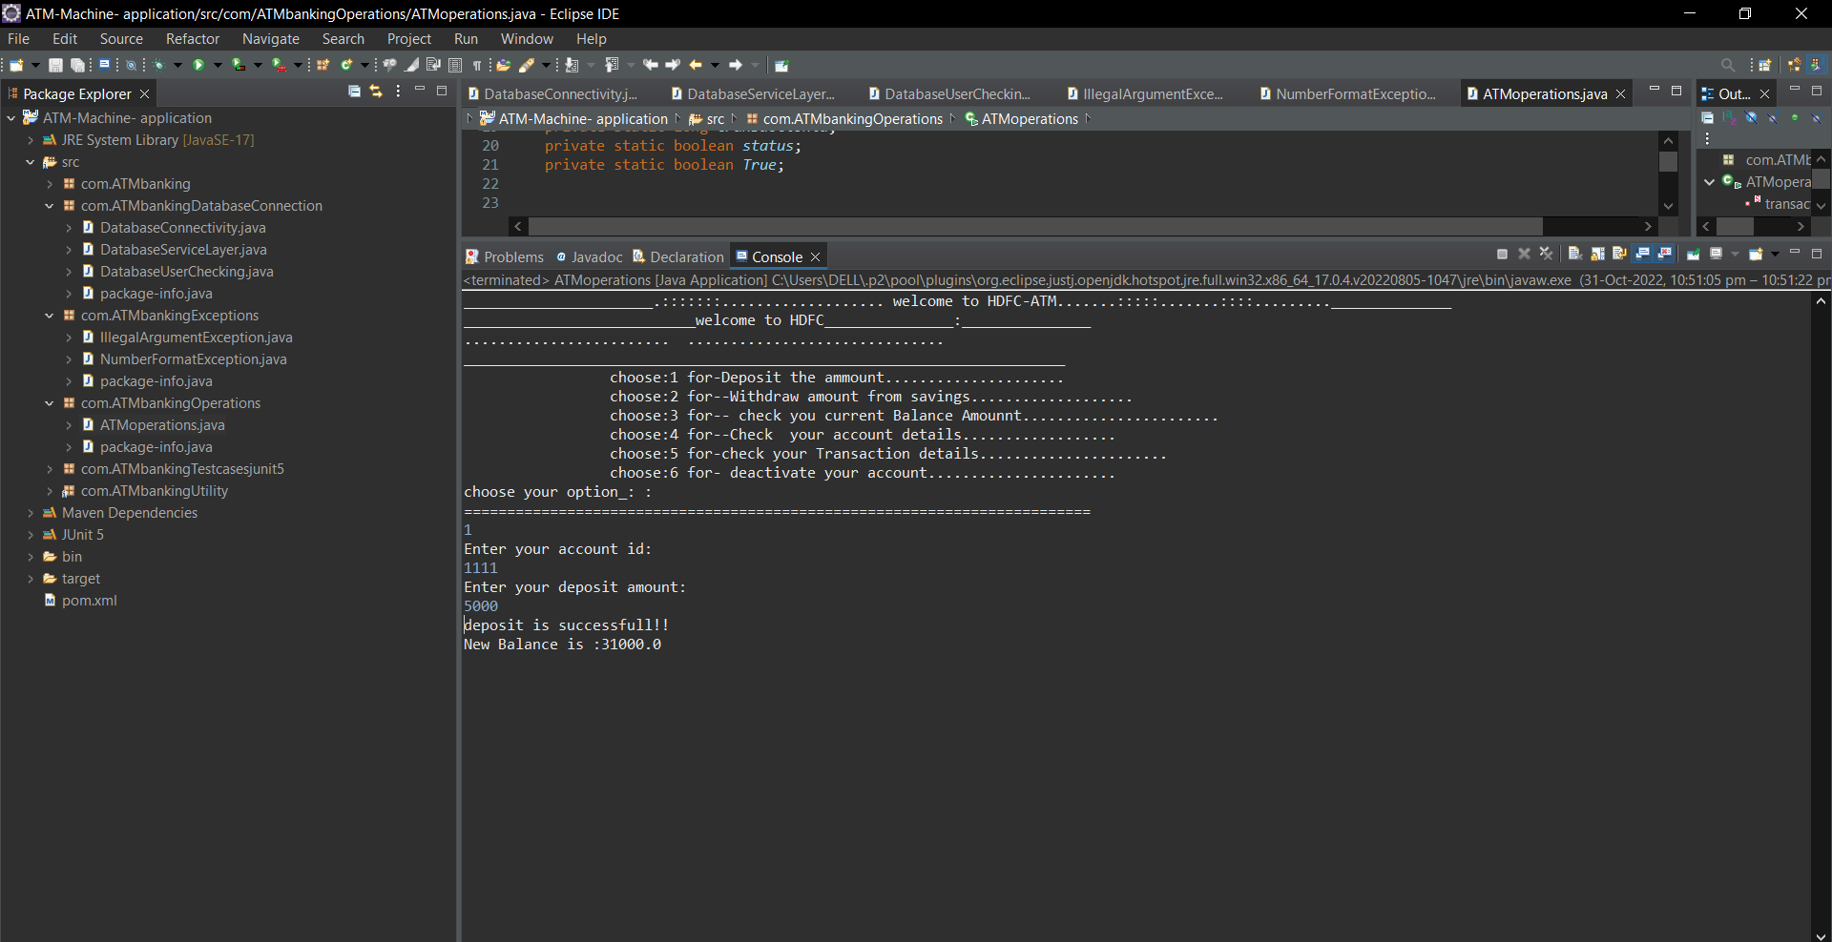

*Function Withdrawal):*

To Withdrawal the amount into the account choose “**OPTION 2”.it** shows withdraw account from savings amount on the console. They need to enter correct account Id and user name. After enter the user Name and Account id the user need to enter the withdrawal amount they want to withdrawal into the account.

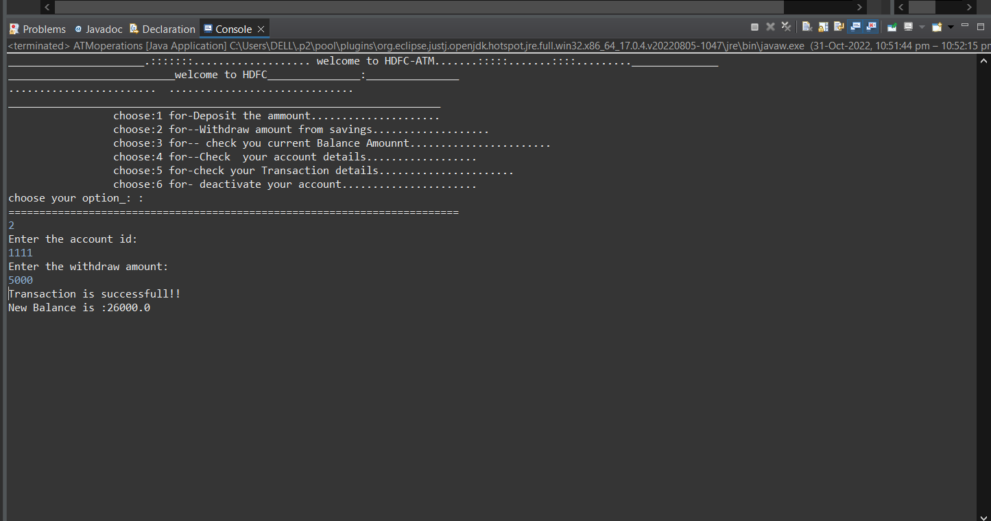

*Function Balance checking:*

To current amount balance into the account choose “**OPTION 3”.it** shows current balance amount on the console. They need to enter correct account Id and user name. After enter the user Name and Account id it shows the current balance amount in the console.

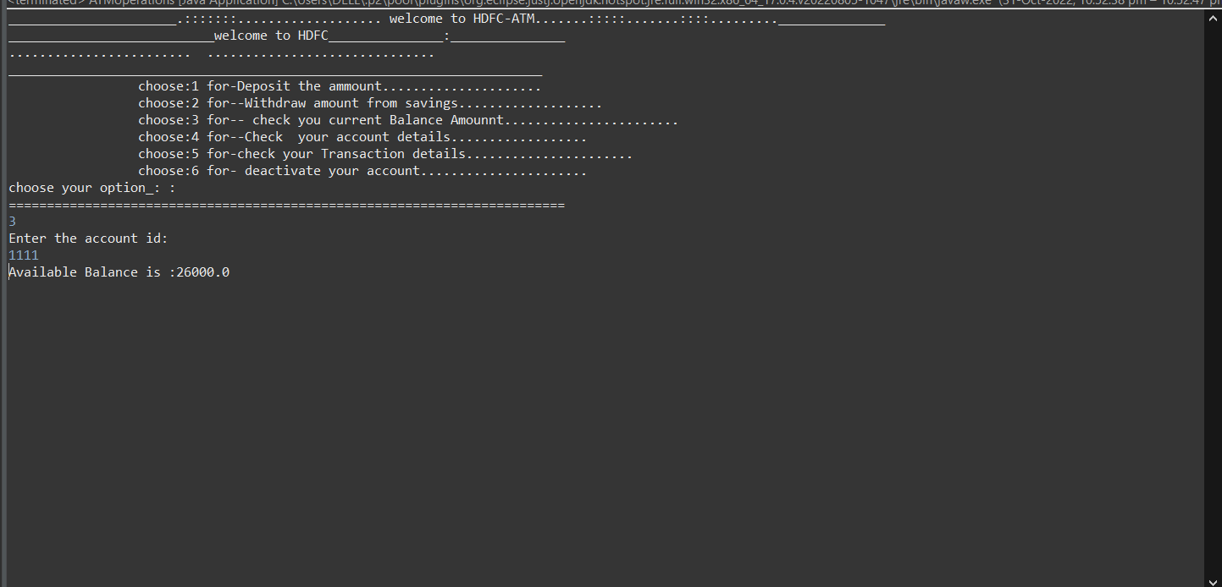

*Function account details:*

To check the account details choose “**OPTION 4”.it** shows account details on the console. They need to enter correct account Id and user name. After enter the user Name and Account id it shows the account details in the console.

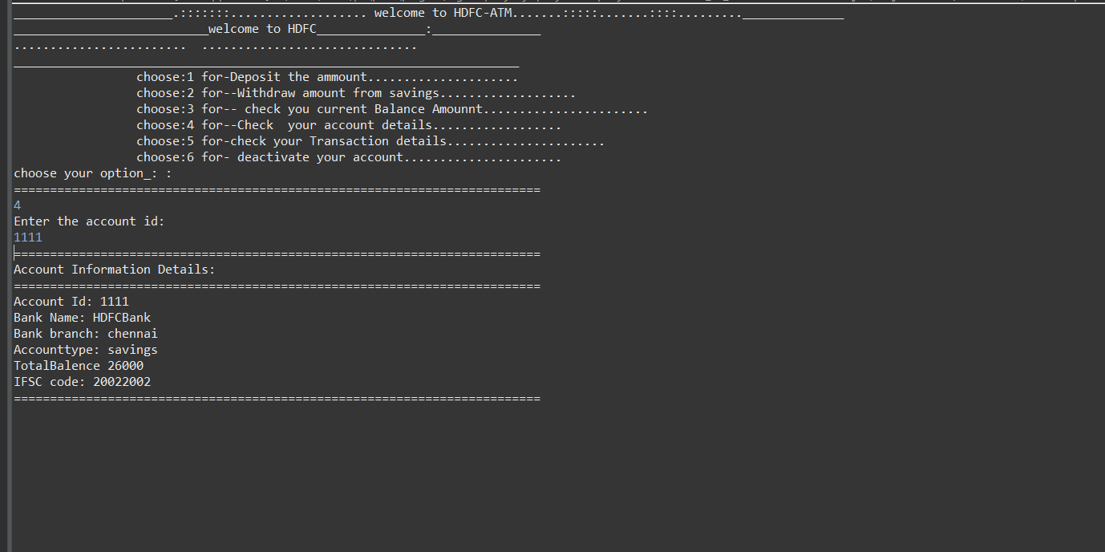

*Function checking Transaction details :*

check transaction details into the account choose “**OPTION 5”.it** shows transaction details on the console. They need to enter correct Transaction Id and user name. After enter the user Name and Transaction id it shows the current balance amount in the console

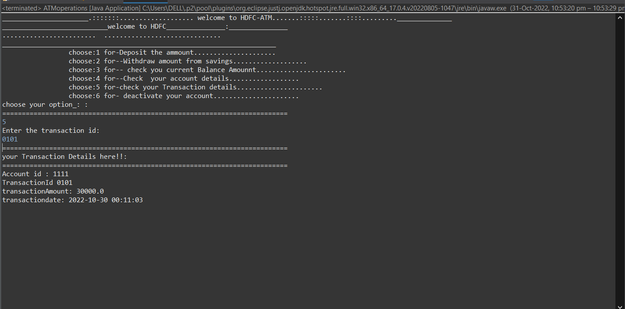.

*Function Deactivate account:*

To deactivate the account choose “**OPTION 6”.it** shows “are you sure” on the console. They need to enter yes or no. After enter the valid response it shows the account details in the console.

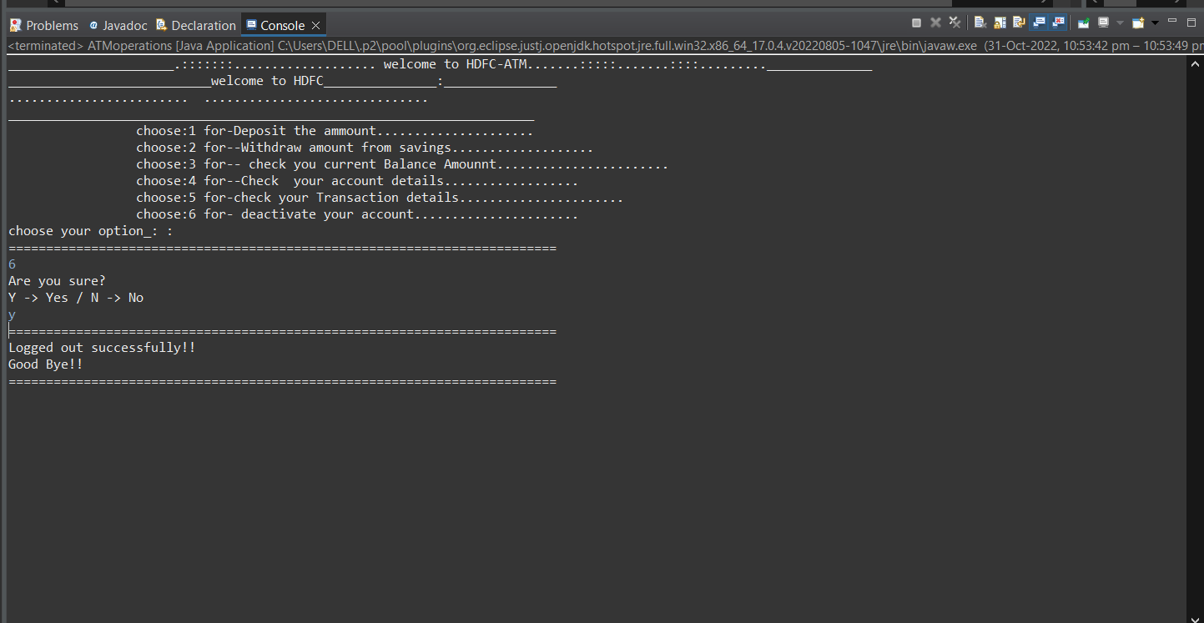

# JAVA DATABASE CONNECTIVITY EXPLANATION

*Function database connectivity*

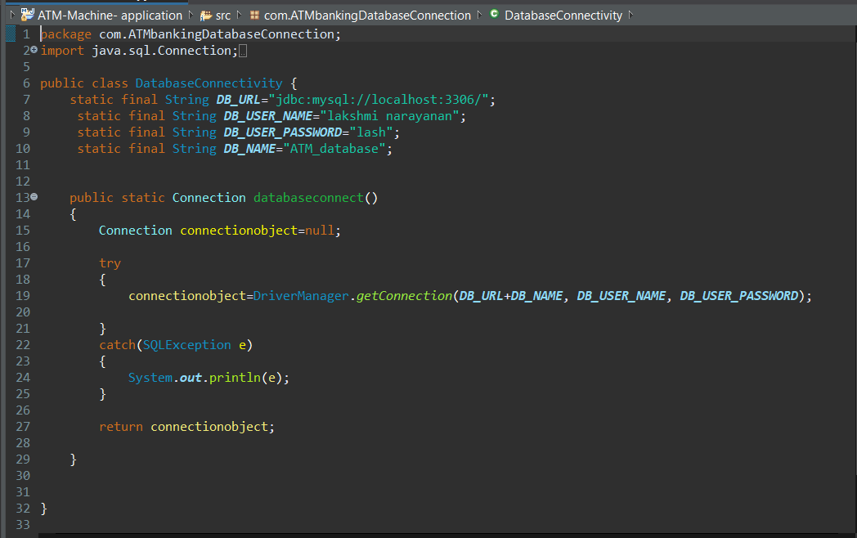

*Function use checking for users data’s are existing in a database or not:*

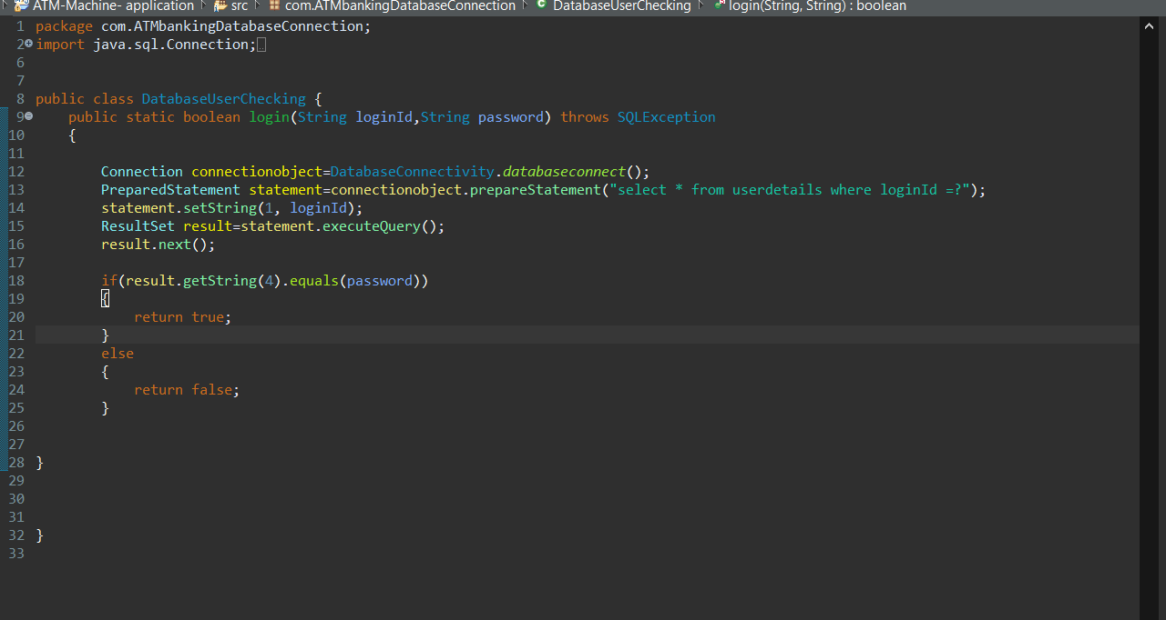

*Function service layer(deposit)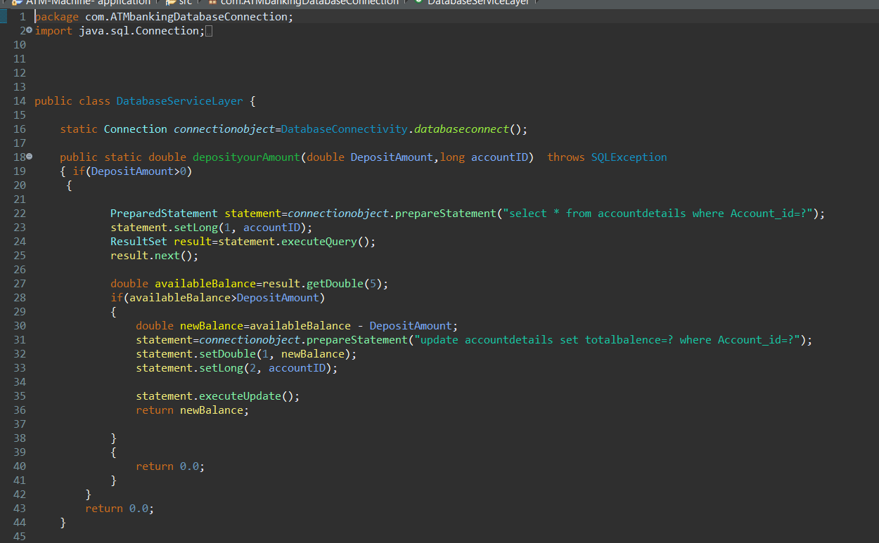withdrawal amount* 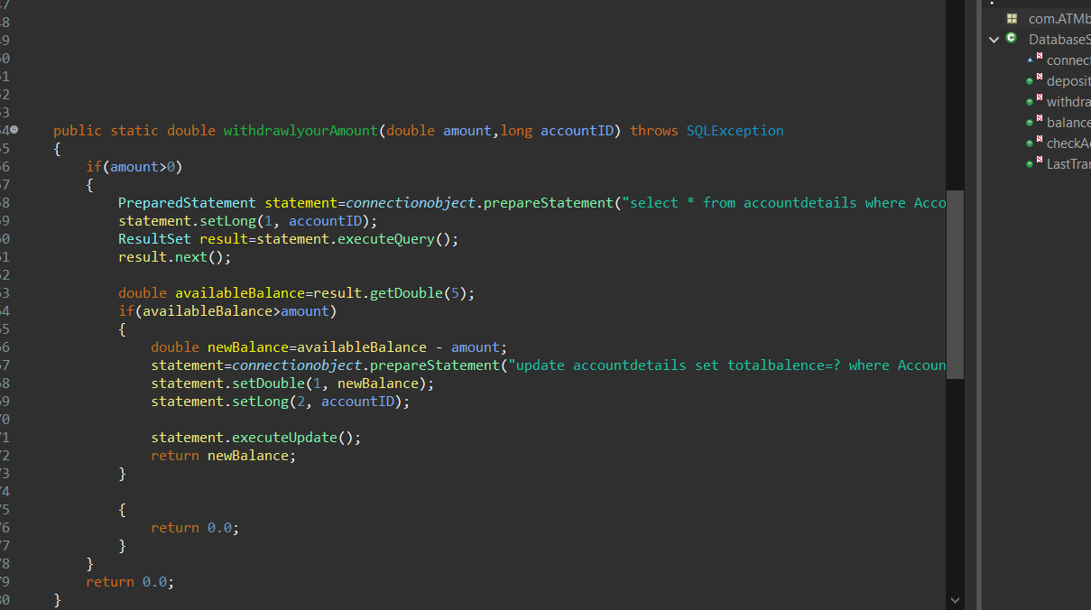

*Balance check/account details/transactiondetailes*

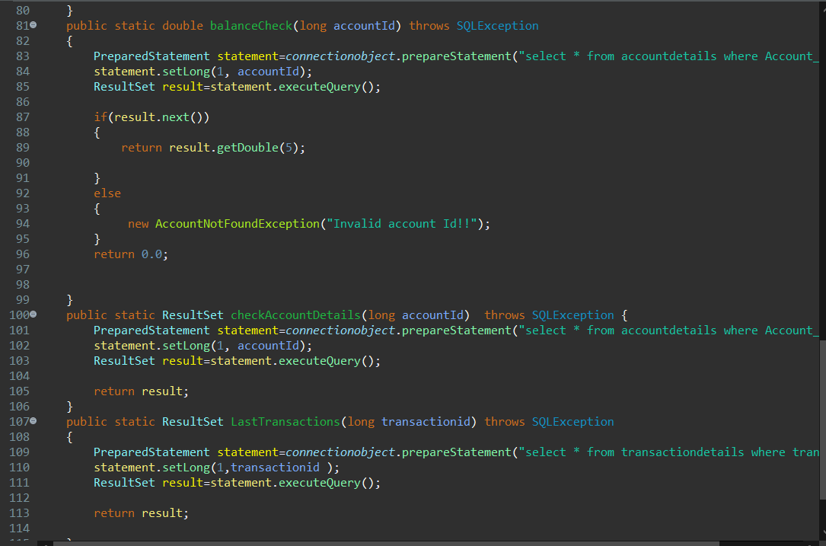

*Account details in MYSQL database:*

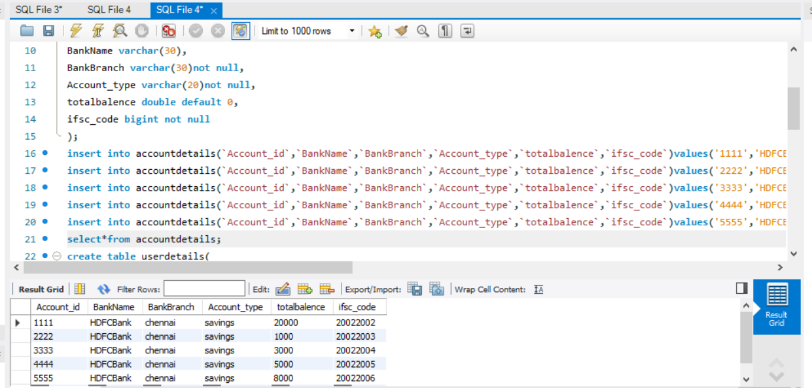

*user details in MYSQL database:*

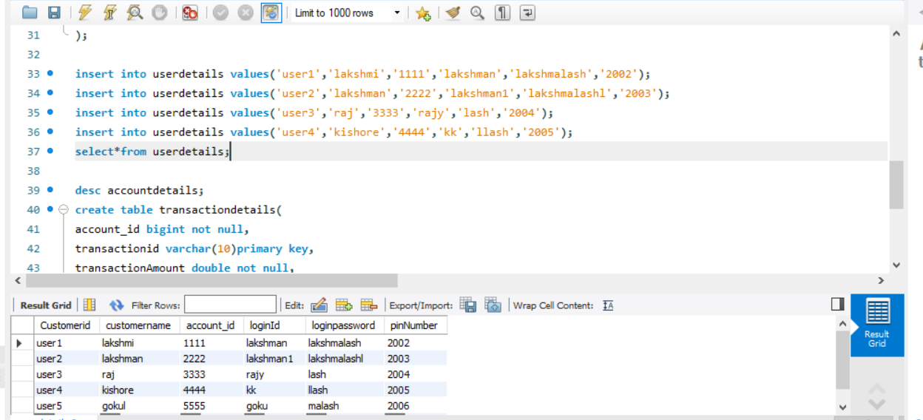

*Transaction details in MYSQL database:*

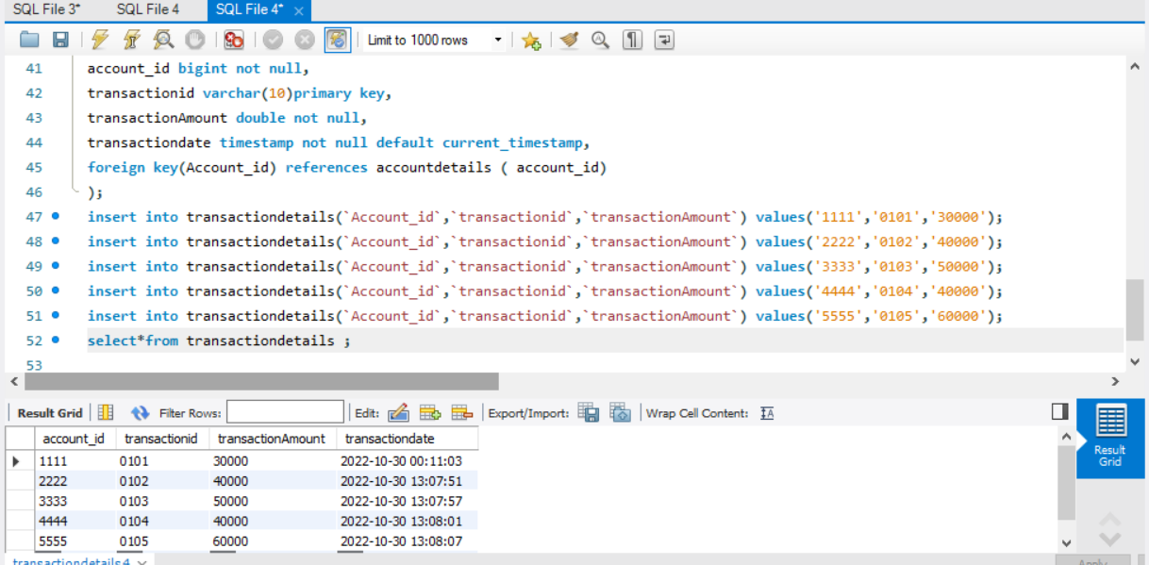

# JAVA EXCEPTION CLASS EXPLANATION

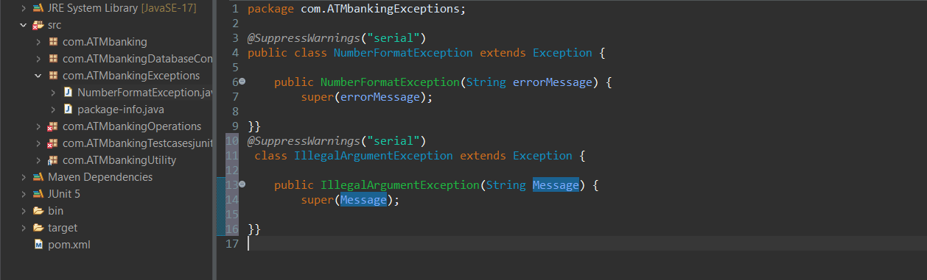

# JUNIT TEST CASES EXPLANATION

*Test cases for our excepted output is matches with the actual output or not:*

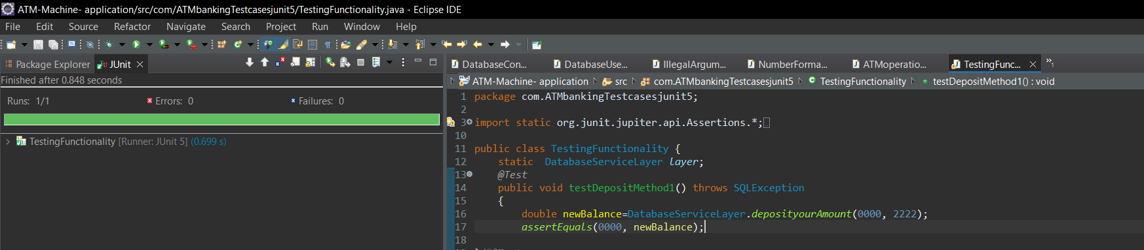

*Assert equals not equals:*

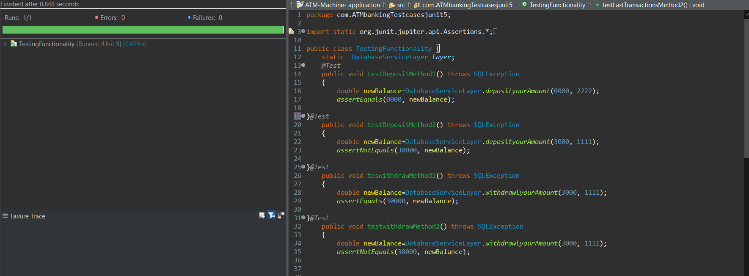

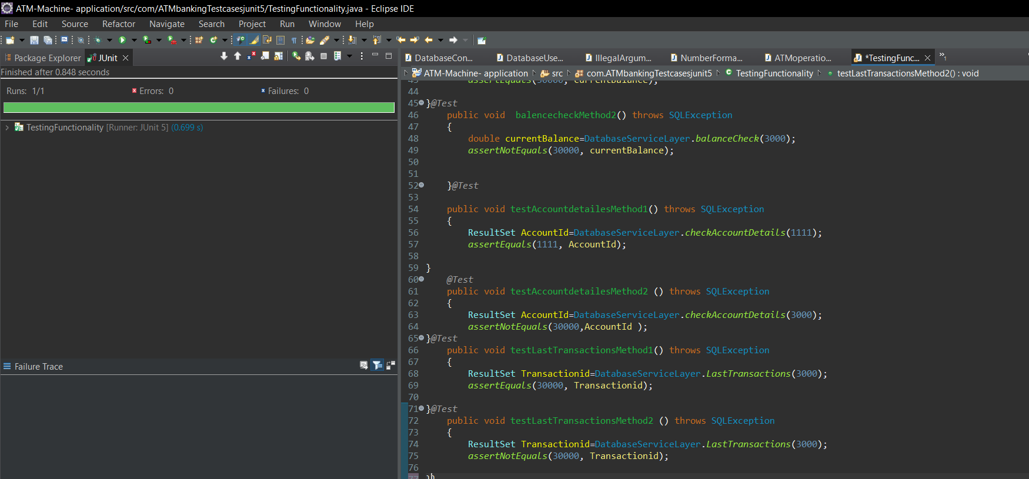

# JAVA CODE FOR USER INPUT VALIDATION :



 